FACULTY EVALUATION
Programme Name: Social Entrepreneurship Program (SEP)- Growth MASTERCLASS Module 1 Kenya (2nd March 2026 - 6th March 2026)
Session: Business Plan reviews
Faculty Name: Loise Wanjiru Oburu
No. of Respondents: 5
No. of Participants: 10
Evaluation Parameter | (%) Individual Score | (%) Programme Average
Punctuality (Commencement and Completion of Sessions) | 96 | 93
How well do you understand the core concepts presented? | 100 | 95
Rate your confidence in applying the new skills learnt | 88 | 88
Degree of Faculty preparedness for the sessions | 100 | 95
Content and methodology of the program | 100 | 96
Quality of class and group discussions | 96 | 89
The information presented in the course is relevant to my work (ministry) | 100 | 97
Average scores | 97 | 93

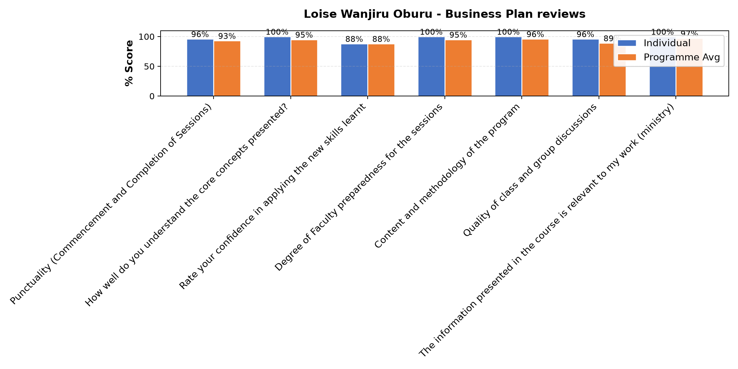

Comments & Feedback
- • Lack of frequent meetings to review our enterprise
- • No. Have taken the Challenge and ready to implement.
- • The lack of being present in the project physically
- • Lack of sufficient funds
SUBMITTED THROUGH:
SBS Evaluation Automation System

